**DAILY ONLINE ACTIVITIES SUMMARY**

|  |  |  |  |  |  |  |  |  |
| --- | --- | --- | --- | --- | --- | --- | --- | --- |
| **Date:** | **28/07/2020** | | | | | **Name:** | **NAIPUNYA VINOD NAIK** | |
| **Sem & Sec** | **IV SEM & A SECTION** | | | | | **USN:** | **4AL18CS050** | |
| **Online Test Summary** | | | | | | | | |
| **Subject** | | **OBJECT ORIENTED CONCEPTS DESCRIPTIVE TEST-2** | | | | | | |
| **Max. Marks** | | **30** | | **Score** | | | **N/A** | |
| **Certification Course Summary** | | | | | | | | |
| **Course** | **1) SHELL CODE ETHICAL HACKING COURSE**  **2) ANDROID APP DEVELOPMENT WITH DEPENDENCIES**  **3) GOOGLE CLOUD PLATFORM BIG DATA AND MACHINE LEARNING FUNDAMENTALS** | | | | | | | |
| **Certificate Provider** | | | **1) UDEMY**  **2) UDEMY**  **3) COURSERA** | | **Duration** | | | **1) 34 MIN**  **2) 1.5 HRS**  **3) 2 WEEKS** |
| **Coding Challenges** | | | | | | | | |
| **Problem Statement: HACKERRANK PROBLEM STATEMENT** | | | | | | | | |
| **Status: EXECUTED** | | | | | | | | |
| **Uploaded the report in Github** | | | | | **YES** | | | |
| **If yes Repository name** | | | | | <https://github.com/naipunya-naik/Online-Coding-platform-coding/blob/master/Loops_28-07-2020.cpp> | | | |
| **Uploaded the report in slack** | | | | | **YES** | | | |

Online Test Details: (Attach the snapshot and briefly write the report for the same).

TODAY OBJECT ORIENTED CONCEPTS DESCRIPTIVE TEST-2 WAS CONDUCTED ON 28TH JULY 2020.

* SUBJECT:- OBJECT ORIENTED CONCEPTS
* CONDUCTED BY:- MS.SHILPA
* FROM 9.30 AM TO 10:15AM
* DURATION:- 45 MIN
* NO.OF QUESTIONS:- 4
* TOTAL MARKS:- 30
* MARKS WILL BE PROVIDED SOON

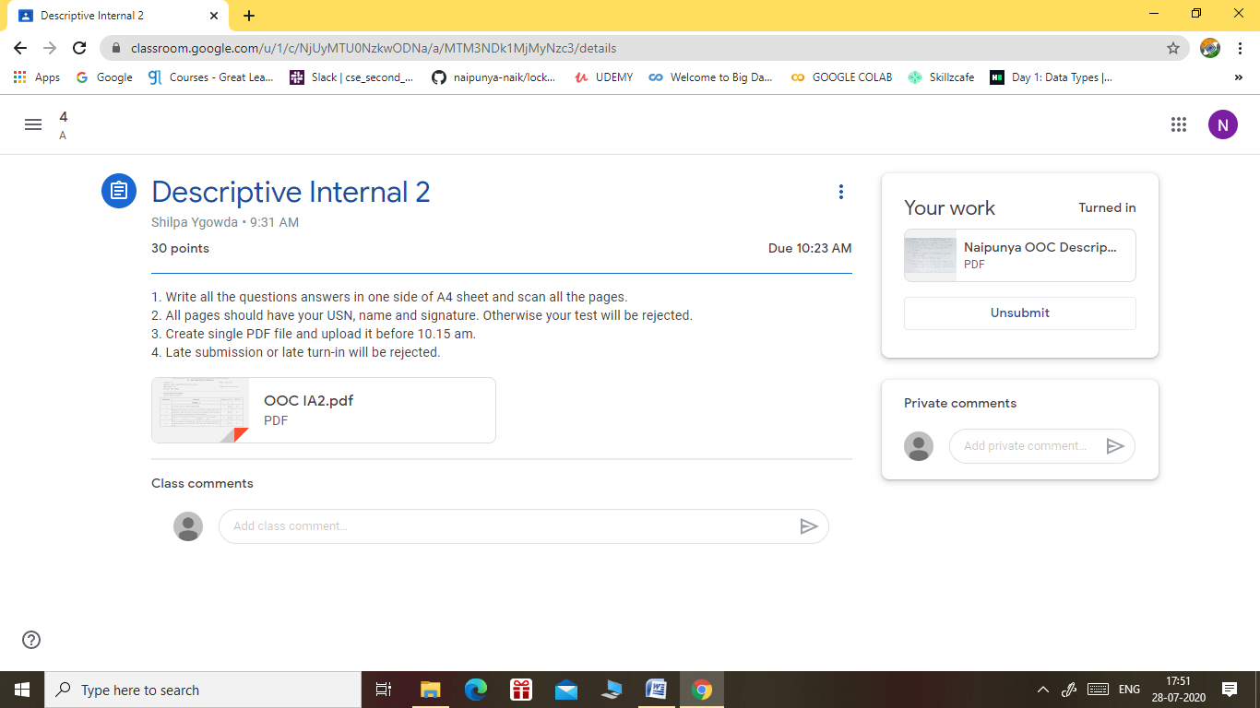

Certification Course Details: (Attach the snapshot and briefly write the report for the same).

CERTIFICATION COURSE NAME:- SHELL CODE ETHICAL HACKING COURSE

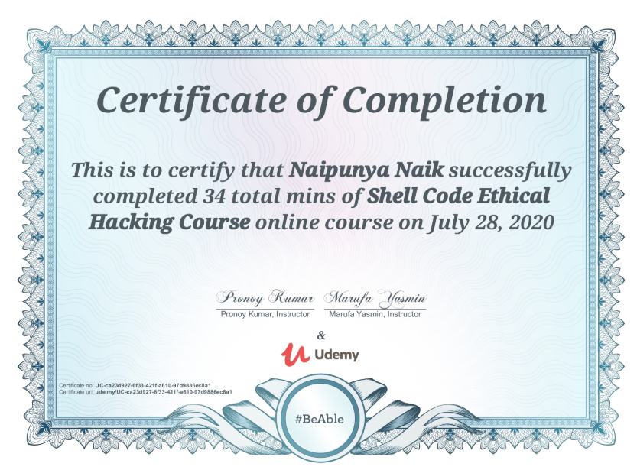

CERTIFICATION COURSE NAME:- ANDROID APP DEVELOPMENT WITH DEPENDENCIES



CERTIFICATION COURSE NAME:- **GOOGLE CLOUD PLATFORM BIG DATA AND MACHINE LEARNING FUNDAMENTALS**



Coding Challenges Details: (Attach the snapshot and briefly write the report for the same).

PROBLEM STATEMENT:-

**Task**  
Given an integer, , print its first  multiples. Each multiple  (where ) should be printed on a new line in the form: n x i = result.

**Input Format**

A single integer, .

**Constraints**

**Output Format**

Print  lines of output; each line  (where ) contains the  of  in the form:  
n x i = result.

**Sample Input**

2

**Sample Output**

2 x 1 = 2

2 x 2 = 4

2 x 3 = 6

2 x 4 = 8

2 x 5 = 10

2 x 6 = 12

2 x 7 = 14

2 x 8 = 16

2 x 9 = 18

2 x 10 = 20

I ATTEMPTED THE QUESTION AND PASSED TWO TEST CASES AND UPLOADED IT IN MY GITHUB REPOSITORY.

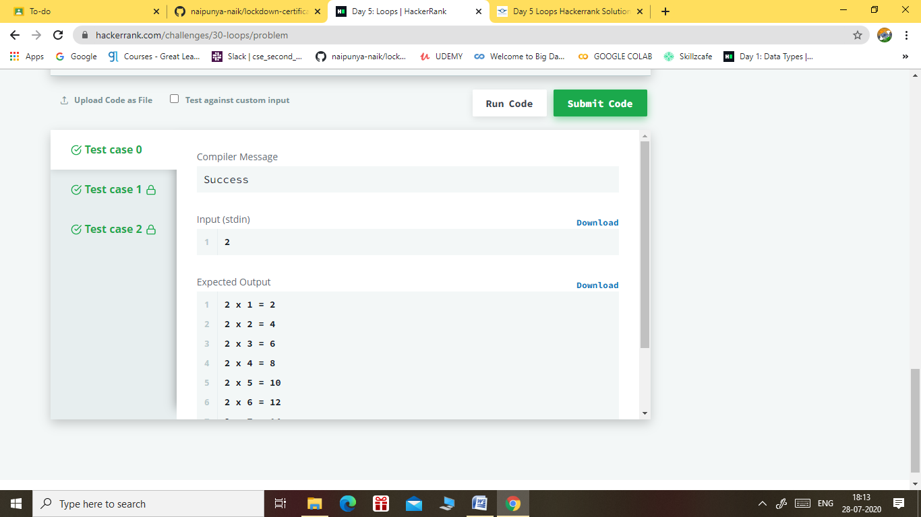

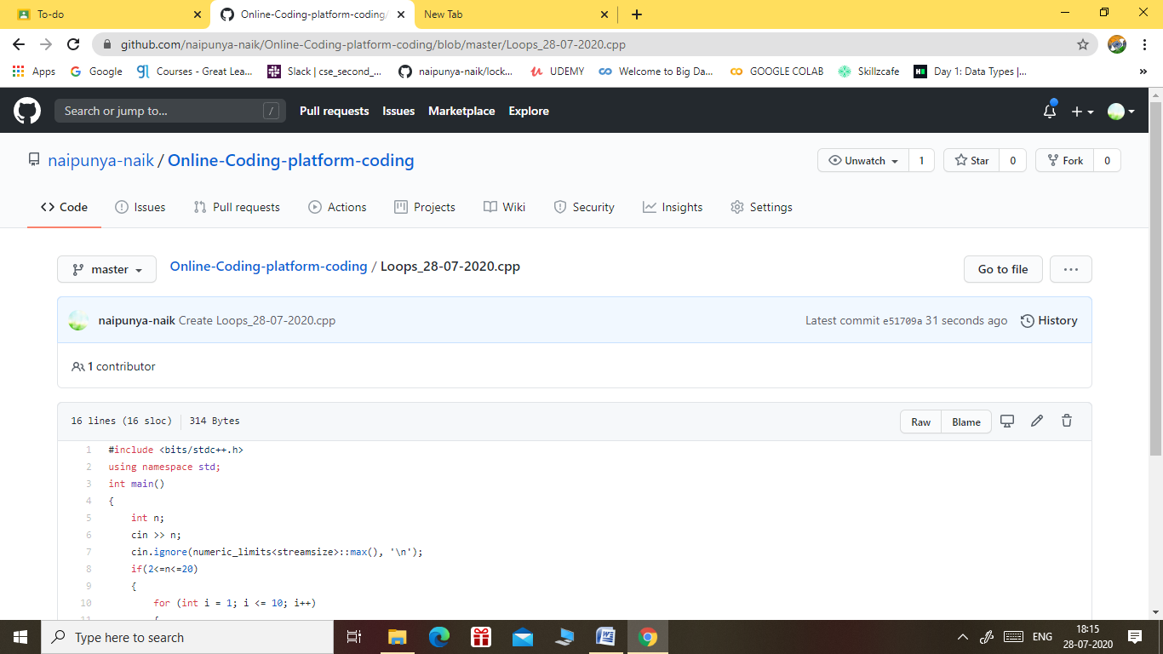

GITHUB REPOSITORY LINK:-

<https://github.com/naipunya-naik/Online-Coding-platform-coding/blob/master/Loops_28-07-2020.cpp>